Name: Sergio Gutierrez

bitbucket Repo: <https://bitbucket.org/SergioZGutierrez/homework/src/master/>

Homework 4

Folder containing homework 4:

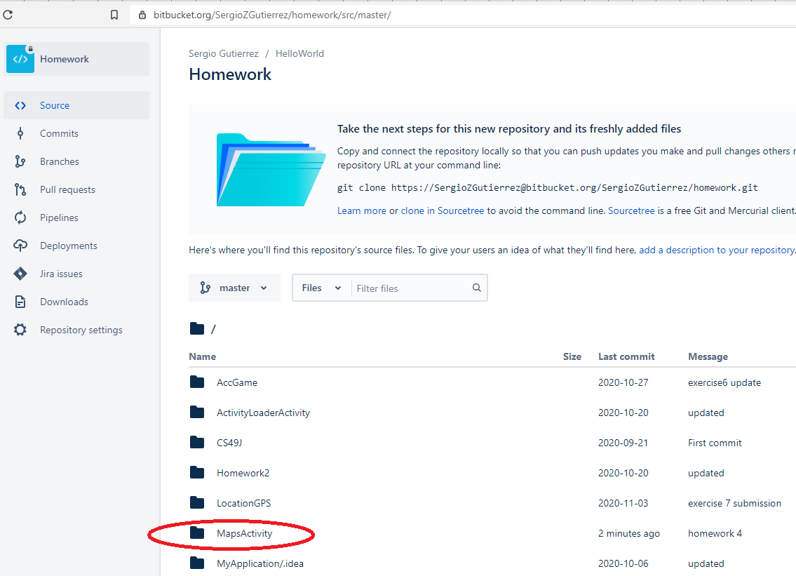

Homework 4 outputs:

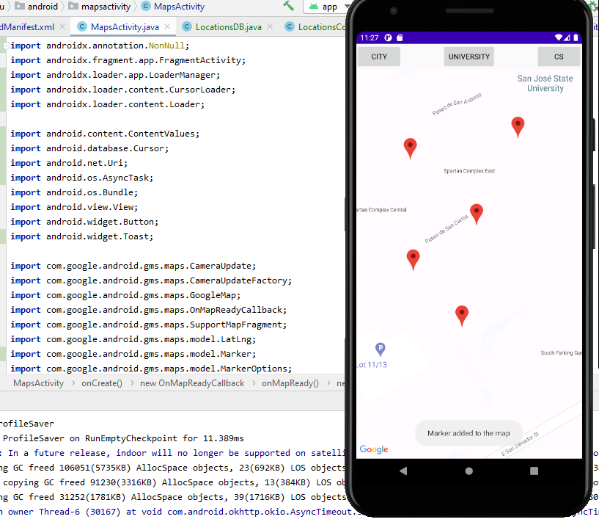

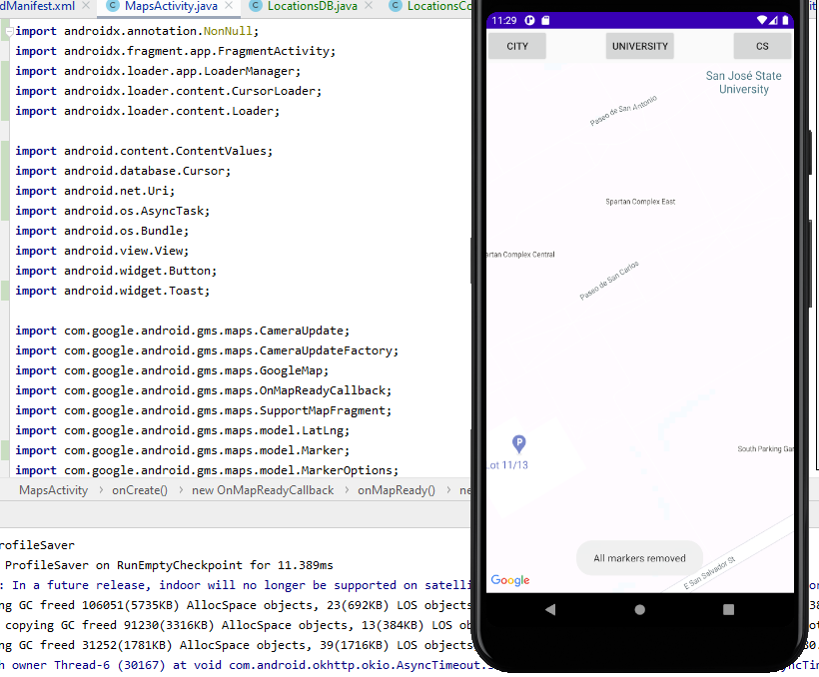

The exact pathway of where the .java files are located in my repository are:

<https://bitbucket.org/SergioZGutierrez/homework/src/master/MapsActivity/app/src/main/java/edu/sjsu/android/mapsactivity/>